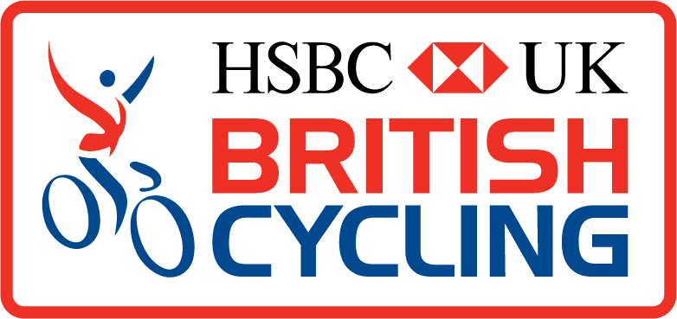
INCIDENT REPORT
This form should be completed where injury, illness or property damage has been sustained by any party during a recognised British Cycling event or activity, including formally organised and registered events, club activities and all coaching, training, ride leading and instructing. It should also be used to report incidents that did not result in injury, illness, or damage – but had the potential to do so.

The form should be completed by an appropriate person, normally the organiser of an event or activity, but may also be completed by an appointed Chief Commissaire or Referee, Event Safety Officer, Coach, Ride Leader, Cycle Training Instructor or other appropriate club or event official.

Day & Date of Incident : |  | Time :
Name & Type of  Event / Activity :  (please include Event URN) |  | Event URN :
Incident Location / Venue :
(include address & postcode if possible)
Name of
Organiser :
Name & Role of (where applicable)
Other Responsible Official :

What Happened? (please provide a factual account of the incident)

Who was involved ? What injuries / illness were suffered ? What property was damaged ?
(further details can be provided on a separate sheet if necessary)

Full Name : |  | Involved as :
Email / Tel : |  | Member No :
Injury (or illness) : |  | Property Damage :
First Aid Treatment Provided : (state if ‘none given’ / ‘refused’) / Referred to : / Recommendations :

Full Name : |  | Involved as :
Email / Tel : |  | Member No :
Injury (or illness) : |  | Property Damage :
First Aid Treatment Provided : (state if ‘none given’ / ‘refused’) / Referred to : / Recommendations :

Full Name : |  | Involved as :
Email / Tel : |  | Member No :
Injury (or illness) : |  | Property Damage :
First Aid Treatment Provided : (state if ‘none given’ / ‘refused’) / Referred to : / Recommendations :

Witnesses (please provide full details of all witnesses. Further details can be provided on a separate sheet if necessary)

Full Name : |  | Involved as :
Address : |  | Postcode :
Email / Tel : |  | Member No :

Full Name : |  | Involved as :
Address : |  | Postcode :
Email / Tel : |  | Member No :

Additional Information (please provide any further information that you feel may be useful if the incident needs to be investigated)

Reported by :
Print Name : |  | Signed :
Position / Role : |  | Date :
Member No. : |  | Email / Day Tel. :

This form should be sent to British Cycling headquarters as soon as possible
but no later than within 3 days of the incident, by email to: incident@britishcycling.org.uk
or by post to: Legal & Insurance Officer, British Cycling, Stuart Street, Manchester M11 4DQ

For internal use only :
Received by : …………..… Date : …………….. Ref. : …………….. Sent to : ..………………………………… CSM / CED / R&P
Cycling Discipline : RO / TR / XC / DH / 4X / CX / BMX / CS Activity Type : NR / R / T
At Fault ? : Y / N / ? Cat. : EV / RA / R2R / MV / NEG / CLI / PED / ANI / RR / CL / RE / HI
EV=Event / RA=Racing / R2R=Rider to Rider / MV=Motor Vehicle / CLI=Coaching, Leading & Instructing / PED=Pedestrian / ANI=Animal / RR=Road Rage / CL=Club
RE=Rider Error / HI=Highway Defect

