Course Description V162/11 - 11 miles
Start on southern side of Thorner Lane at TP 9/81H quarter of a mile east of Holme Farm Lane. Proceed on Thorner Lane (becomes Holme Farm Lane) to T-junction where left (CARE, give way) on to Milner Lane. Continue towards Thorner where (extreme care – give way) bear left up Church Hill. Continue along Bramham Road (becomes Thorner Road) to junction with Thorner Lane. Turn sharp left (care)and continue on Thorner Lane to complete one lap (5.56 miles). Repeat circuit to finish at starting point (11.12 mls).
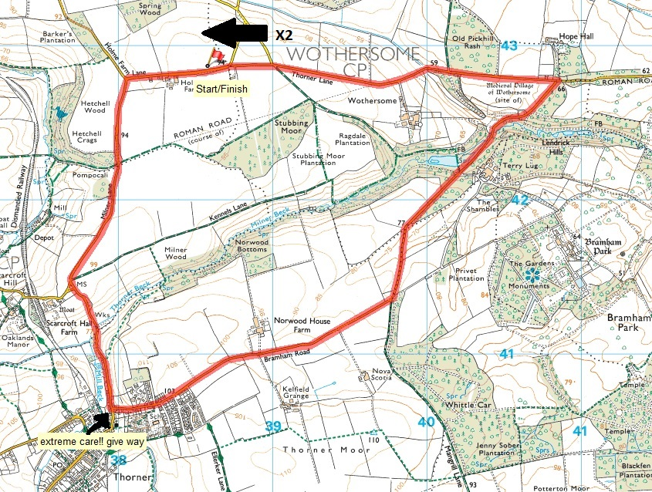

Course Description V212 – 10 miles
V212 Start approx. 3.5 miles south of Boroughbridge in entrance to A168 from old A1 (now a long lay-by) at a point approx. 1 yard before “clearway” sign. Turn left on to A168 and proceed to Walshford roundabout (4.72 miles). Encircle roundabout and retrace along A168 to Arkendale Road, to finish adjacent to central bollard at a red paint mark.
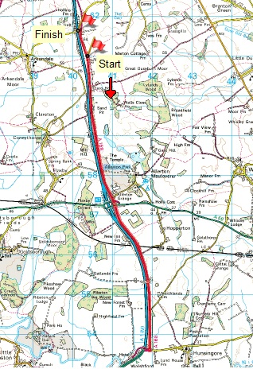
Course Description V227 - 15 miles
Start on South side of slip road from A59 to A168, just before “clearway” sign. Proceed towards A168, turn left to join A168 southbound. Proceed to Walshford traffic island (2.1 miles). Encircle island and proceed northwards to reach Boroughbridge south taffic island (9.7 miles). Encircle island and proceed southwards to finish at mark on kerb, approx. 150 yards of long lay-by alongside red wall (15 miles).
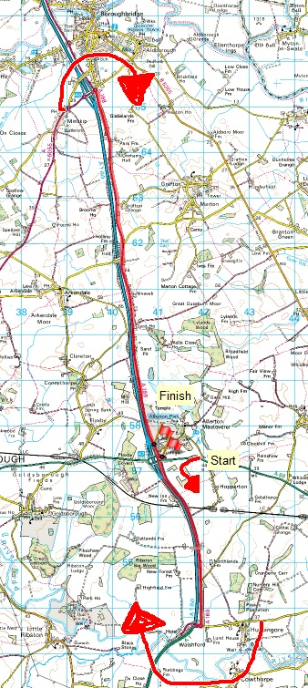
Course Description V235 – 25 miles
Start approx. 3.5 miles south of boroughbridge, in entrance to a168 from old a1 (now a long layby) at a point approx. 1 yard before "clearway" sign. turn left on to a168, and proceed south to walshford traffic island (4.72 mls). encircle island and retrace north along a168, past start, to boroughbridge south traffic island (12.27 mls) encircle island and retrace south on a168 to walshford traffic island (2nd time) (19.86 mls). encircle island and proceed north on a168, to finish at northern end of crash barrier protecting road direction sign, on west side of road, approx. 150yds south of arkendale road (25 miles).
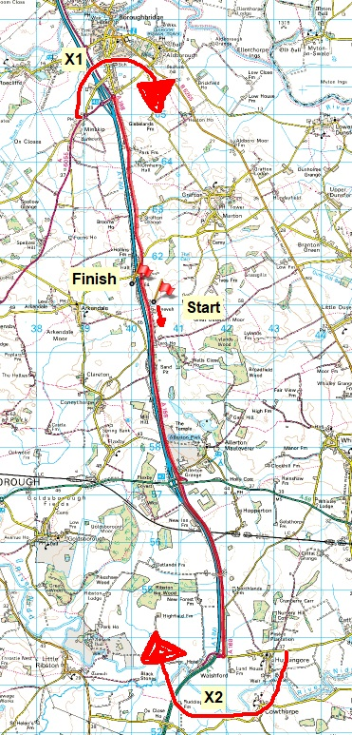
Course Description V318 – 10miles
Start on east side of A162 Tadcaster to Sherburn road at paint mark on kerb, 10 yds before road sign “A162 Ferrybridge, A64 York” just north of bridge over A64 dual Carriageway. Proceed South on on A162,via Towton, and Barkston Ash, to roundabout at start of Sherburn by-pass (5.0 mls). Encircle island and retrace outwood route to the finish at southern gatepost of first field entrance after crossing A64 fly over (opposite start point)
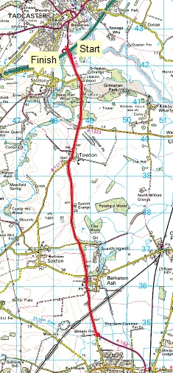

Course Description V328 – 15 miles
Start on A162 approximately 1.5 miles south of Tadcaster, 200 yards south of entrance to Grimston Park and adjacent to third cat’s-eye north of entrance to Greatwood House (on western side of road). Proceed south on A162 to Sherburn in Elmet TI where left along Sherburn by-pass. Go straight ahead at TI with B1222 to next TI, at South Milford. Encircle island and retrace route past start. Finish at power pole 27, approximately 200 yards after passing over A64 flyover and just before electricity sub station (on eastern side of road). (15 miles)
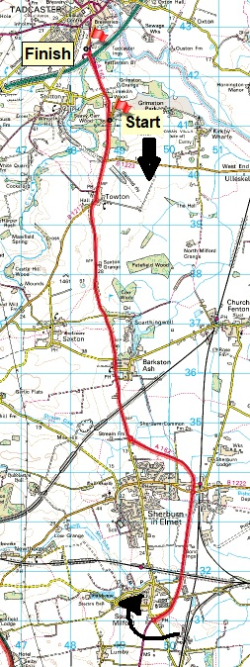
Course Description V910A – 10miles
Start on unclassified road (Holyrood Lane) leading from Ledsham to A1246, just South of Selby Fork, at northern edge of grate on east side of road adjacent to road sign, 65 yards west of A1246. Proceed to junction with A1246, where turn left to Selby Fork TI - junction A63 (0.20 mls). Take first exit (straight ahead) on to A63, and continue to Micklefield TI (Boot & Shoe) (1.74 mls). Encircle island and retrace to Selby Fork TI (3.35 mls). Take 2nd exit on to A1246 and continue south to Fairburn North TI (4.55 mls). Encircle island and retrace to Selby Fork TI (2nd time) (5.75 mls). Take first exit on A63 and continue to Micklefield TI (2nd time) (7.3 mls). Encircle island and retrace to Selby.
Fork TI (8.91 mls). Take second exit on to A1246 and continue south to finish at start of kerbstone at southern side of tarmac-ed entrance to field, 200 yds north of Fairburn North T1. (10 mls)

